**PCA Analysis and Clustering of Ca Activity Data**

I calculated maximum intensity projection image from one of my recordings, and select ROI’s by hand as a ground truth selection, then I created a mask using ImageJ.

Max intensity projection:

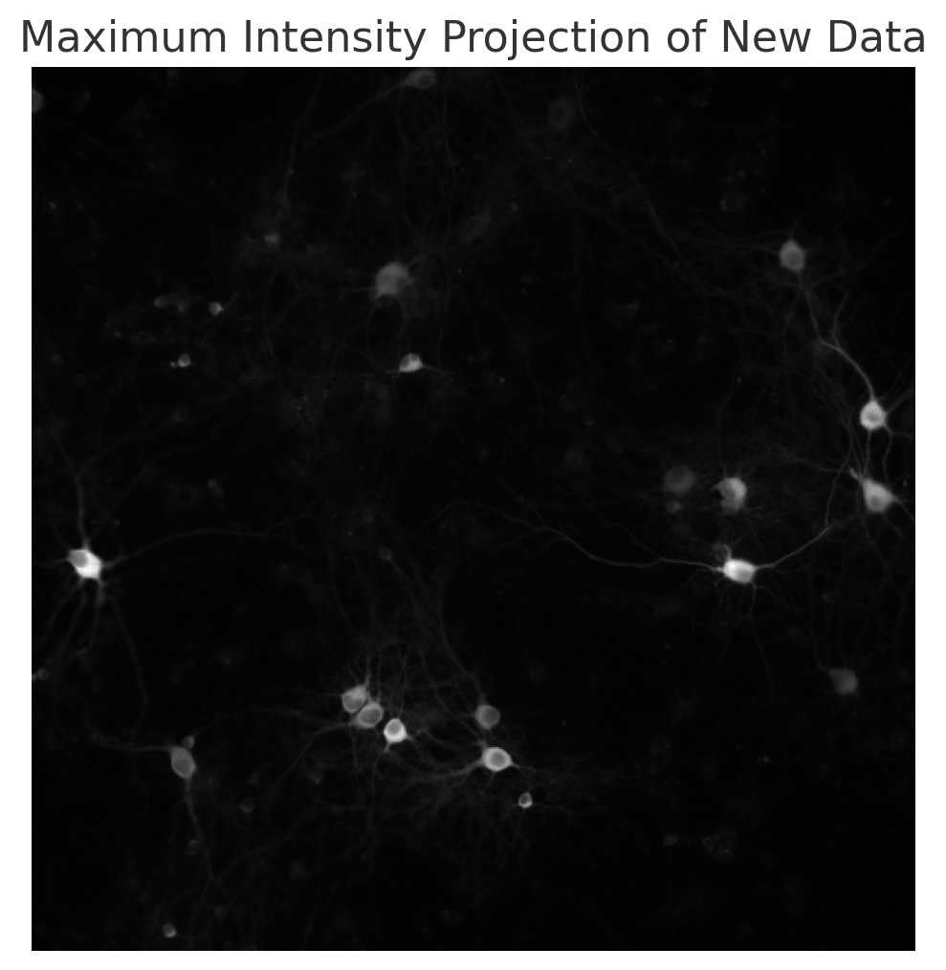

Masked image:



I want to write a python code that makes this steps automatically.

#loaded tiff video file

#normalized the images so their pixel values mostly fall between 0 and 1

#converted the images as float32 <- the data type that is fast for GPU computation

import numpy as np

import tifffile

# Define the normalization function

def normalize99(img):

X = img.copy()

x01 = np.percentile(X, 1)

x99 = np.percentile(X, 99)

X = (X - x01) / (x99 - x01)

return X.astype(np.float32)

# Load the TIF file

file_path = 'path_to_your_tif_file.tif'

tif = tifffile.TiffFile(file_path)

# Read the images into a list and apply normalization

normalized_frames = [normalize99(frame.asarray()) for frame in tif.series[0].pages]

# Compute the Maximum Intensity Projection (MIP)

mip = np.max(normalized_frames, axis=0)

mip image:



# Scikit-image provides a function named try_all_threshold that applies various thresholding methods to an image and displays the results side by side for easy comparison. I thought that this part can be asked to user.

from skimage.filters import try_all_threshold

import matplotlib.pyplot as plt

# normalize intensity across image

max_img_filtered = max_img.copy() / gaussian_filter(mip, 100)

# high pass filter

max_img_filtered = max_img_filtered - gaussian_filter(mip, 10)

max_img_filtered = normalize99(max_img_filtered)

fig, ax = try_all_threshold(mip, figsize=(10, 8), verbose=False)

plt.show()

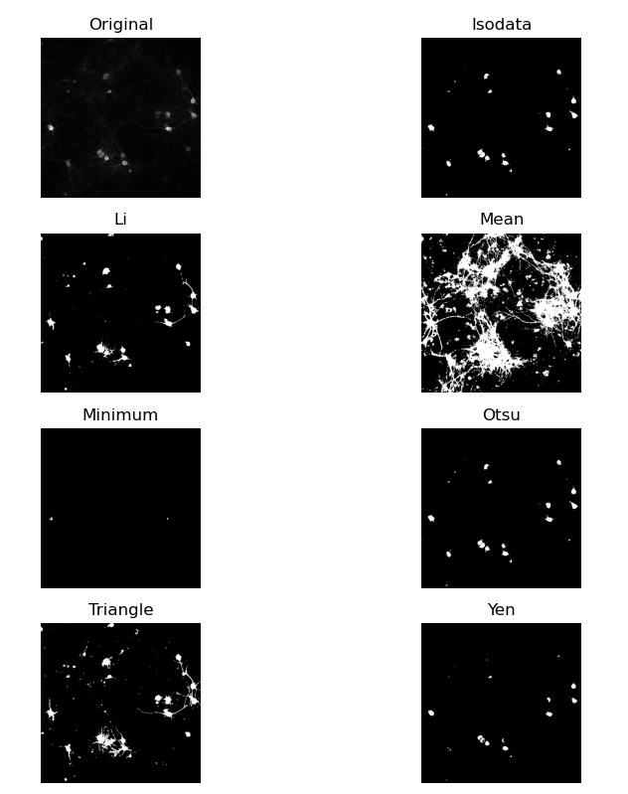

In this project I don’t need to get all the cells, but in long term I need to use deep learning algorithms for proper segmentation.

This is the results that I get using Cellpose, and it’s super impressive https://www.cellpose.org/:

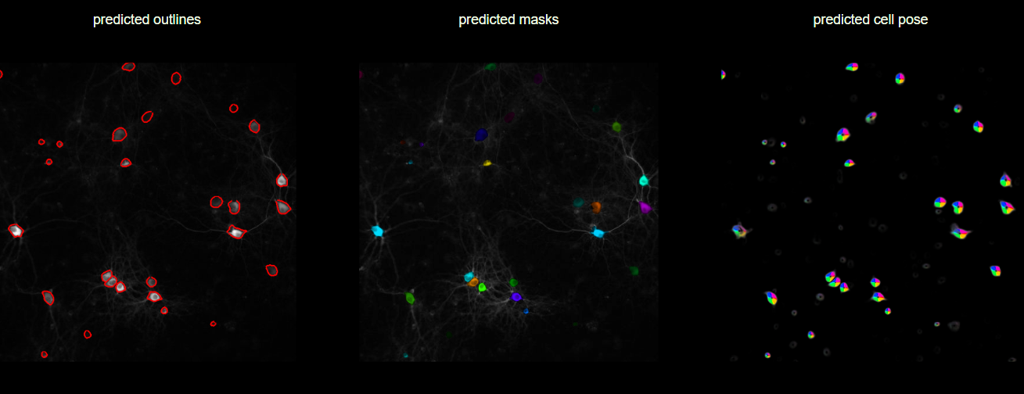

# Calculate the Otsu threshold

threshold_value = filters.threshold_otsu(mip)

# Generate the binary mask

binary_mask = mip > threshold_value

# Display results

fig, ax = plt.subplots(1, 2, figsize=(12, 5))

# Histogram and Otsu threshold

ax[0].hist(mip.ravel(), bins=256)

ax[0].axvline(threshold_value, color='r', linestyle='dashed', linewidth=2)

ax[0].set_title('Histogram of Normalized MIP')

ax[0].set_xlabel('Intensity Value')

ax[0].set_ylabel('Frequency')

# Binary mask

ax[1].imshow(binary_mask, cmap='gray')

ax[1].set_title('Binary Mask of Normalized MIP')

ax[1].axis('off')

plt.tight_layout()

plt.show()

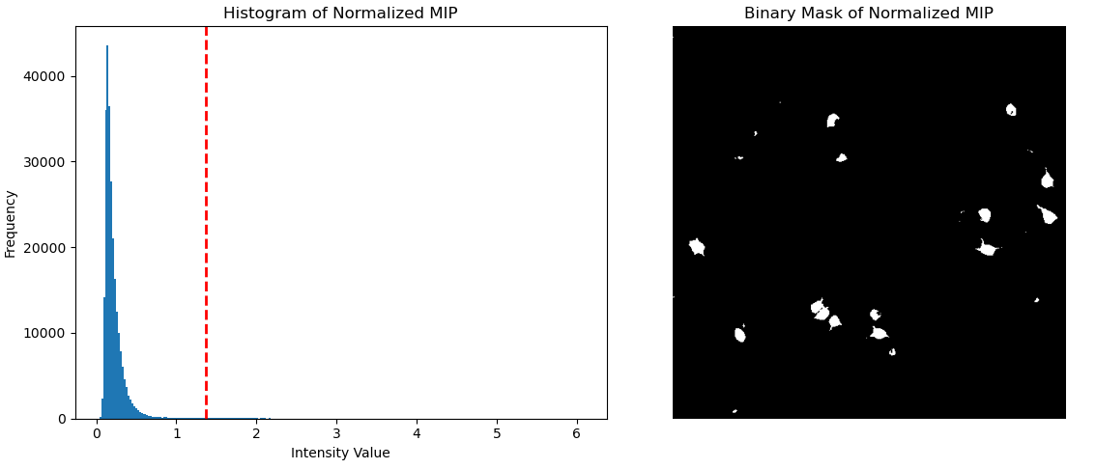

#Assigning a different colour for each cell

import numpy as np

import matplotlib.pyplot as plt

from skimage.measure import label

from skimage.color import label2rgb

import random

# Function to generate a unique color for each label

def generate_unique_colors(num_labels):

random.seed(42) # Seed for reproducibility

colors = [(0, 0, 0)] # Background color

for _ in range(1, num_labels + 1):

# Generate a unique color for each label, avoiding too dark colors

colors.append((random.random()*0.6 + 0.4, random.random()*0.6 + 0.4, random.random()*0.6 + 0.4))

return colors

# Label the connected regions in the binary mask

labeled_mask = label(binary_mask, connectivity=2)

# Generate unique colors

num_labels = labeled_mask.max()

unique_colors = generate_unique_colors(num_labels)

# Create an RGB image with the unique colors

colored_labeled_image = np.zeros((*labeled_mask.shape, 3), dtype=float)

for label, color in enumerate(unique_colors):

colored_labeled_image[labeled_mask == label] = color

# Display the colored labeled image

plt.figure(figsize=(6, 6))

plt.imshow(colored_labeled_image)

plt.title('Labeled Cells with Unique Colors')

plt.axis('off')

plt.show()

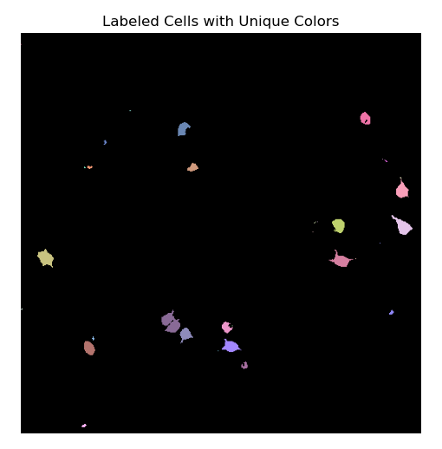

Here I have two problems: 1. Cells with very small radius, 2. Different cells identified as one single cell. I will correct this issue in the future.

cell_intensities = {label: [] for label in range(1, num_labels + 1)}

# Iterate over each frame to calculate average intensities

for frame in normalized_frames:

for label in cell_intensities.keys():

cell_mask = labeled_mask == label

cell_intensity = frame[cell_mask].mean()

cell_intensities[label].append(cell_intensity)

# Plotting

fig, axs = plt.subplots(2, 1, figsize=(12, 10))

# Display the labeled mask

colored_labeled_image = np.zeros((*labeled_mask.shape, 3), dtype=float)

for label, color in enumerate(unique_colors):

colored_labeled_image[labeled_mask == label] = color

axs[0].imshow(colored_labeled_image)

axs[0].set_title('Labeled Cells with Unique Colors')

axs[0].axis('off')

# Display the activity data

for label, intensities in cell_intensities.items():

axs[1].plot(intensities, color=unique_colors[label], label=f'Cell {label}')

axs[1].set_title('Average Intensity Over Time for Each Cell')

axs[1].set_xlabel('Time (Frame Number)')

axs[1].set_ylabel('Average Intensity')

axs[1].legend(bbox_to_anchor=(1.05, 1), loc='upper left', borderaxespad=0.)

plt.tight_layout()

plt.show()

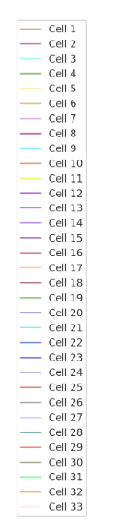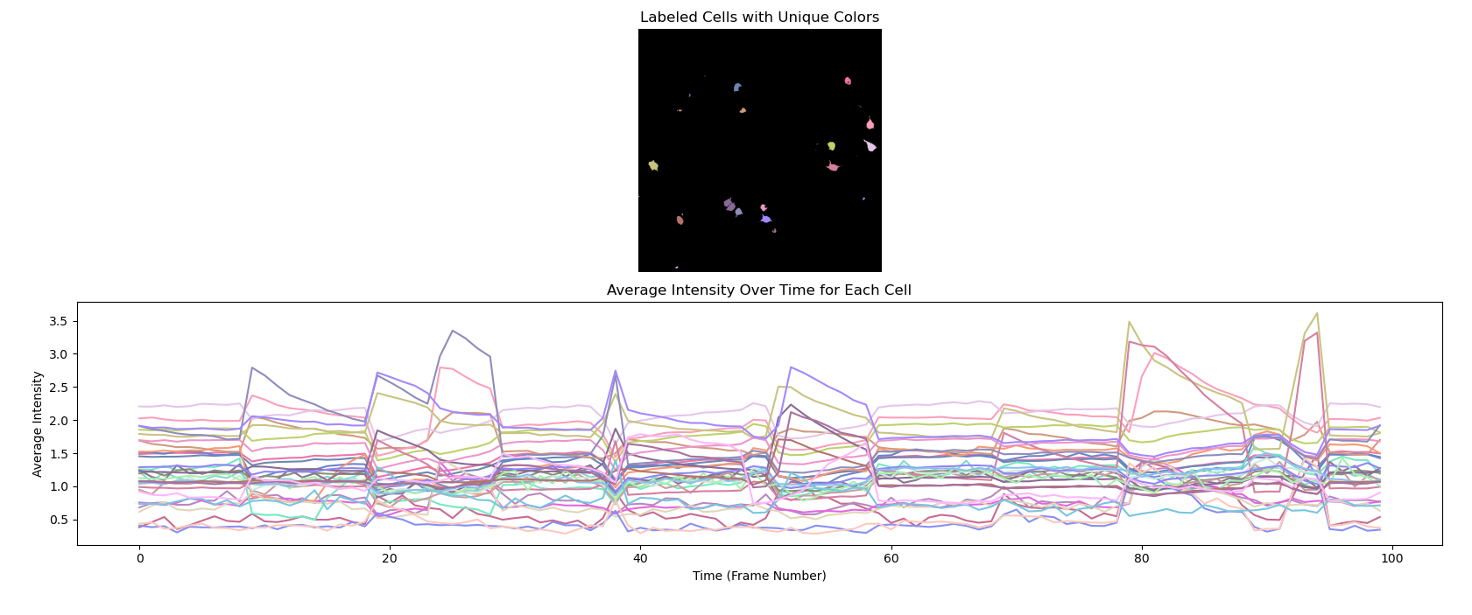

To find the correlation between cells, first I plotted the correlation matrix between cell activities:

# Convert the cell intensities dictionary to a list of lists for easier manipulation

intensity_values = list(cell_intensities.values())

# Convert the list of lists into a NumPy array for easier mathematical operations

intensity_array = np.array(intensity_values)

# Calculate the correlation matrix between the activities of the cells

correlation_matrix = np.corrcoef(intensity_array)

# Display the correlation matrix

plt.figure(figsize=(10, 8))

plt.imshow(correlation_matrix, cmap='viridis', interpolation='nearest')

plt.colorbar()

plt.title('Correlation Matrix between Cell Activities')

plt.xlabel('Cell Number')

plt.ylabel('Cell Number')

plt.show()

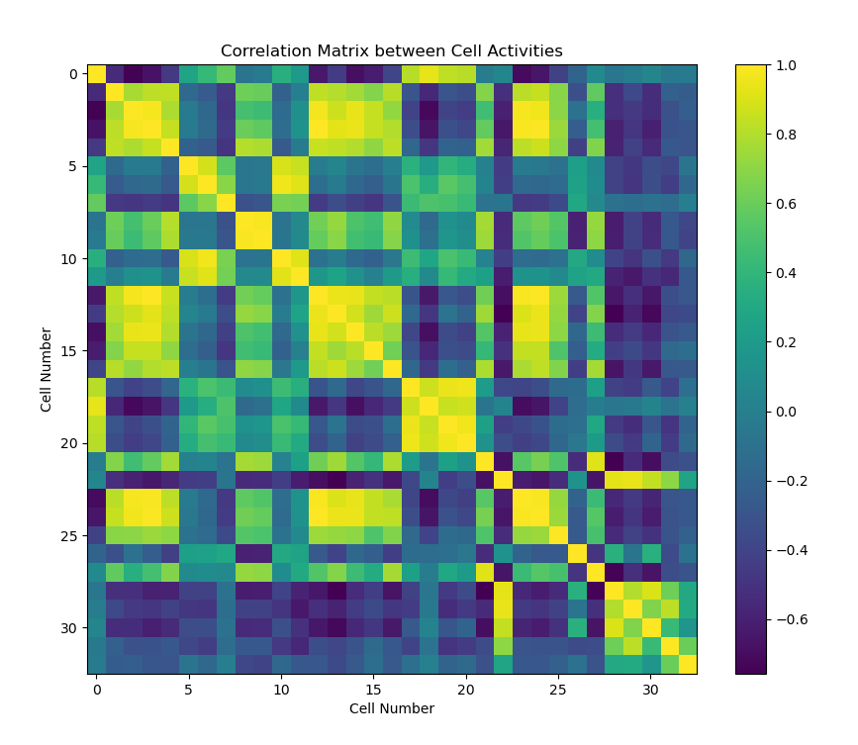

A value close to 1 indicates a strong positive correlation, close to -1 indicates a strong negative correlation. Values near 0 indicate little to no linear relationship between the activities of the cells. Then, I calculated the PCA and clustered them with Kmeans clustering method.

from sklearn.decomposition import PCA

from sklearn.cluster import KMeans

pca = PCA(n_components=2)

pca.fit(correlation_matrix)

components = pca.components_

explained_variance = pca.explained_variance_

# Plot the first two principal components

plt.figure(figsize=(12, 6))

for i, (component, variance) in enumerate(zip(components, explained_variance), start=1):

plt.subplot(1, 2, i)

plt.bar(range(len(component)), component)

plt.title(f'PC{i} - Variance: {variance:.2f}')

plt.xlabel('Cell Number')

plt.ylabel('Component Weight')

plt.tight_layout() # Correct placement

plt.show()

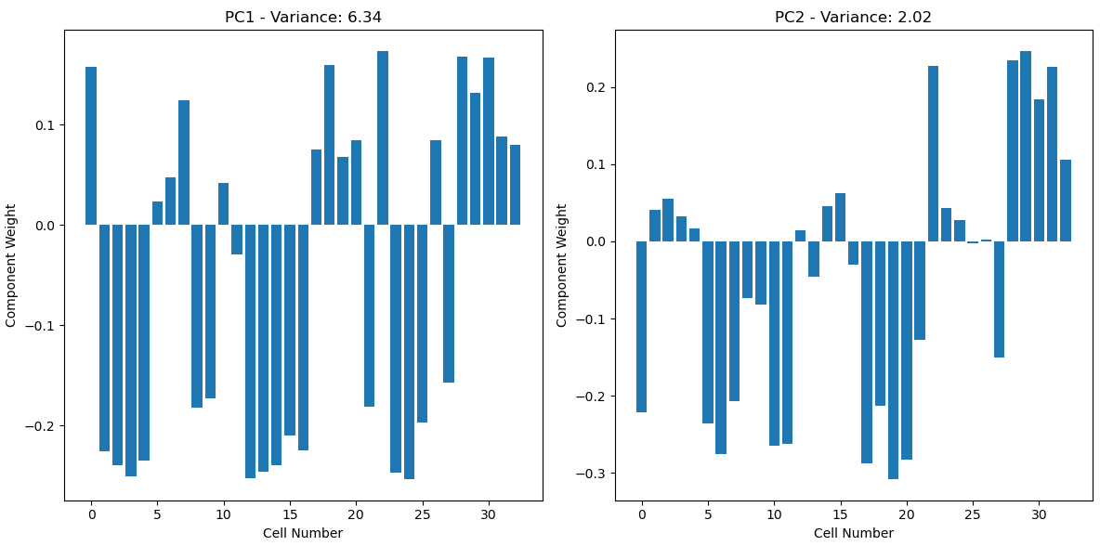

# Project the original correlation matrix data onto the first two principal components

pca_projection = pca.transform(correlation_matrix)

inertia = []

for n_clusters in range(1, 11):

kmeans = KMeans(n_clusters=n_clusters, random_state=42)

kmeans.fit(pca_projection)

inertia.append(kmeans.inertia_)

optimal_clusters = 3 # Adjust this value based on the Elbow method result

kmeans = KMeans(n_clusters=optimal_clusters, random_state=42)

cluster_labels = kmeans.fit_predict(pca_projection)

# Plot the clusters with cell numbers

plt.figure(figsize=(10, 8))

colors = plt.cm.viridis(np.linspace(0, 1, optimal_clusters))

for i, color in zip(range(optimal_clusters), colors):

plt.scatter(pca_projection[cluster_labels == i, 0], pca_projection[cluster_labels == i, 1],

color=color, marker='o', edgecolor='k', s=50, label=f'Cluster {i+1}')

# Label each point with its cell number

for i, (x, y) in enumerate(pca_projection):

plt.text(x, y, str(i + 1), color='black', fontsize=9)

plt.title('Clusters of Cell Activities (PCA Projection)')

plt.xlabel('PCA 1')

plt.ylabel('PCA 2')

plt.colorbar(label='Cluster Label')

plt.legend()

plt.tight_layout()

plt.show()

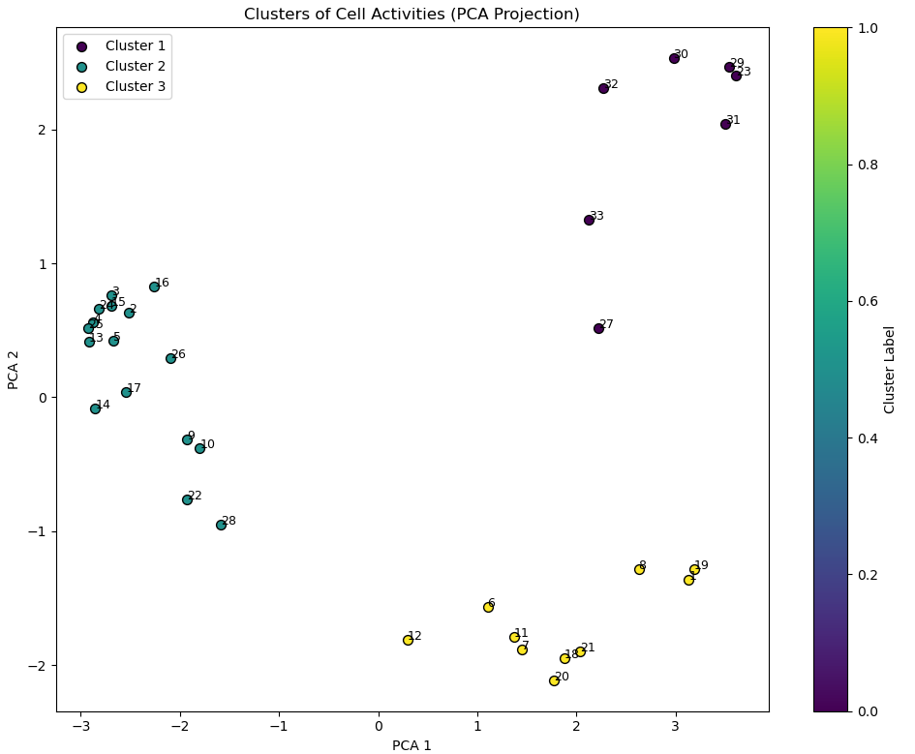

I will apply the same methods to my data after adding a specific drug and see the activity response of the cells. Thank you for reading and many thanks to chatgpt 😊